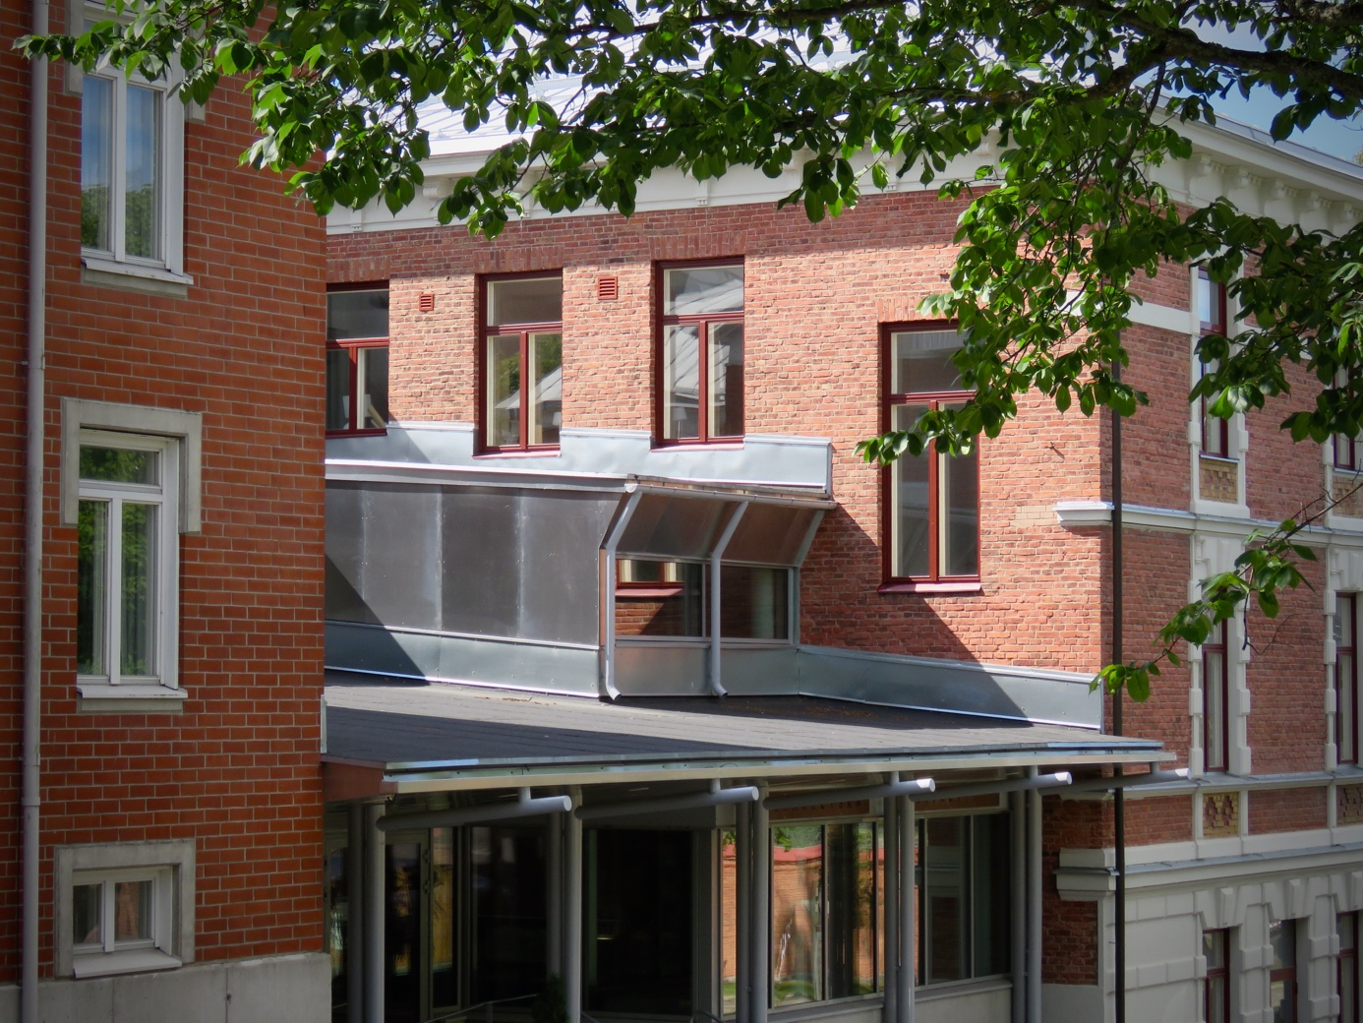
2026–2027
Studies at Efo
EVANGELISKA FOLKHÖGSKOLAN I SVENSKFINLAND
KORSHOLMSEPLANADEN 2B 65100 VASA
010 327 1610
info@efo.fi www.efo.fi
GROUPS ON CAMPUS AUTUMN 2026

Svenska 1a start their studies in August 2026. The course consists of 20h of lessons per week, distributed over four days. No language- och work practice during term 1. The subjects taught are Swedish, SKR (society, culture and religion) and IT. The second term of the course starts in January 2027.

Svenska 1j started their studies in January 2026 and continue until December 2026. The course consists of 20 h of lessons per week, distributed over four days. Included in the course is a language practice during the Autumn term. The subjects taught are Swedish, SKR (society, culture and religion) and IT.

Svenska 2a start their studies in August 2026. The course consists of 20h of lessons per week, distributed over four days. No language- och work practice during term 1. The subjects taught are Swedish, SKR (society, culture and religion), music and IT. The second term of the course starts in January 2027.

GruVux is Basic Education for Adults which is a programme that spans over 3–4 years. The first group started in August 2025. The programme offers full time studies and includes subjects such as Swedish, maths, environmental studies and health education.

Linje X is Efo:s name for the Folk high school year for students in compulsory education. A new group start their studies in August 2026. The programme offers full time studies and includes a wide range of creative and theoretical subjects.

SCHOOL RULES
Evangeliska folkhögskolan is a Christian school where we take responsibility, show consideration and work in an atmosphere of mutual respect. These school rules apply to all school activities, both inside and outside of school premises.

- We act kindly, respectfully and fairly towards all students and staff.
- We use a friendly and polite way of speaking. We show consideration towards others in the way we express our thoughts and opinions. The school has a zero tolerance for any kind of bullying, violence, discrimination or harrassement.
- We allow ourselves to work in a peaceful environment and avoid distractions. Digital devices (mobile phones, computers, tablets) are used according to the teacher’s instructions. Disturbing use of a phone or other digital devices is forbidden during lessons, and mobile phones should be switched off or turned into silent mode and stored in the student’s bag or pocket. Food and beverages are generally enjoyed during the breaks.
- We allow others to work in a peaceful environment. We are all responsible for creating a positive, encouraging and forgiving learning environment.
- The school is a safe place for everyone. Dangerous objects and substances are strictly forbidden on the school premises.
- We are careful with the furniture and equipment in the school. We clean up after ourselves and leave the school classrooms, cafeteria, common areas and toilets looking welcoming for the next person to use them. We inform the staff if something accidentally breaks.
- Drugs, alcohol, cigarettes, e-cigarettes and snuff are strictly forbidden. Smoking is allowed only in designated areas outside.
- We respect punctuality and are not absent without a reason. Permission to be absent must always be asked for and granted by the teacher before the start of the lesson. For students under the age of 18 their guardian/s is/are responsible for communicating with the school. In case of a longer period of absence a written application must be sent to the teacher by e-mail well in advance in order to be approved by the teacher conference before the period of absence starts. Absence without permission is considered unauthorized absence. The school is obliged to report absence to concerned authorities
- In case of illness please inform your teacher before the first lesson. For sick leave lasting more than three days, a medical certificate from a doctor needs to be submitted. For students under the age of 18 their guardian/s is/are responsible for communicating with the school.
- We participate in festivities, theme days, and excursions organized by the school unless explicitly voluntarily. The school’s working days can be found on the school’s web page
Disruptive students may be removed from the classroom. Failure to follow the shool rules may result in a written warning from the principal. If this proves insufficient the student may be expelled for a certain period of time or to the end of the school year. A student under the age of 18 can be suspended for up to three months.
IMPORTANT DATES SCHOOL YEAR 2026–2027

AUTUMN 2026 | Week | Date |  | Autumn 2026
AUTUMN 2026 | 33 | 13.8.2026 |  | Start of the Autumn term 2026
AUTUMN 2026 | 36 | 1.9.2026 |  | School’s outdoor activity day
AUTUMN 2026 | 39 | 24.9.2026 |  | Independent studies (school closed)
AUTUMN 2026 | 42 | 12.10–18.10.2026 |  | Autumn break
AUTUMN 2026 | 49 | 4.12.2026 |  | Celebration of Finland’s Independence Day
AUTUMN 2026 | 51 | 18.12.2026 |  | Closing of the Autumn term
AUTUMN 2026 | 51–1 | 21.12.2026– 6.1.2027 |  | Christmas break
SPRING 2027 | Week | Date |  | Spring 2027
SPRING 2027 | 1 | 7.1.2027 |  | Start of the Spring term 2027
SPRING 2027 | 6 | 11.2.2027 |  | Theme day: Friendship
SPRING 2027 | 9 | 1.3–7.3.2027 |  | Winter break
SPRING 2027 | 11 | 14.3.2027 |  | Annual school celebration: Efo-vännernas årsfest (Sunday = school day)
SPRING 2027 | 12–13 | 25.3–29.3.2027 |  | Easter break
SPRING 2027 | 18 | 6.5.2027 |  | Ascension Day (school closed)
SPRING 2027 | 21 | 28.5.2027 |  | Closing of the Spring term
 | 22 | 31.5–6.6.2027 |  | Practice Svenska 1a
 | 23 | 7.6–11.6.2027 |  | Practice Svenska 1a

USEFUL INFORMATION
Phone numbers: office 010 327 1610
headmaster 010 327 1601
teachers’ office 050 575 8740
E-mail: info@efo.fi
Wifi: ECguest
Password: vitsippa24

Contact details for the school staff is available on the school website. Members of staff:

Jan Åbacka | headmaster
Niklas Lindvik | assistant headmaster, coordinator Linje X
Ann-Sofie Rönnblom | head teacher Linje S, Swedish teacher
Sofie Granlund | Swedish teacher
Elisabeth Ekstrand | Swedish teacher, coordinator GruVux
Kristina Engman | teacher and counsellor
Anna-Maria Storgård | teacher Linje X
Ann-Katrin Kvist | IT teacher, contact person student health care
Maj-Sofie Teir | financial manager
Carolina Djupsjöbacka | course coordinator
Jessica Sandström | head chef
Yvonne Eklund | cook
Ning Qiu | cook
Mifa Gref | cleaner
Thi Lieu Chau | Cleaner
Lena Holmlund | hostel host

Student card
All students can apply for a student card for discounts at Matkahuolto and VR (bus and train). The student card costs €9,90 (2026–2027). You can apply for the student card online.
Parking
Parking is free in the street around the school. Bicycles can be parked outside the main entrance.

Morning prayer
A short prayer is held every morning in the assembly hall at 10 a.m. Everyone is welcome to join in!

EC Café
You can buy coffee, tea and light refreshments in the café on the first floor.
For all Efo students a morning coffee between 9.45–10.15 and lunch + coffee /tea between 12.30–13.15 are included. You can buy breakfast from 7:30 a.m. Family members who come for lunch pay the full price.
For any dietary requirements, please fill in your details here: https://efo.fi/behov-av-specialkost. To avoid unnecessary waste, please remember to notify the kitchen well in advance whenever you’re absent from school. Call 050 342 6863.
In case of emergency
The general emergency number is 112 (fire brigade, ambulance and police).
Please take note of where all emergency exits, fire-extinguishers and fire points are in the building!
In case of emergency, all students and staff gather in the park area on Strandgatan opposite the school where everyone has to be accounted for. Once outside, notify the teacher so we know that you’re safe.
Camera surveillance
There are recording surveillance cameras in the school areas.
HEALTH CARE
School nurse Hanna Vanhatupa, hanna.vanhatupa@ovph.fi, tel. 040 549 8826
- consulting at Efo every other Tuesday starting from w. 35
- consulting at Rådhusgatan 31 (Alma Adult Education Centre), Monday – Thursday at 8.30–9.30 a.m.
The contact person for health care at Efo is Ann-Katrin Kvist.
All students are offered a medical check-up during the school year

INFORMATION ABOUT FEES

Applies to the Autumn term 2026.

The study fee for part-time students (20h/week) is 1292€ for the Autumn term, and includes teaching, lunch on school days, insurance, all books and learning materials and paper copies. Invoicing is carried out in five installments and the first invoice is sent out after the student confirms their place of study at Efo. The first installment is a non-refundable enrolment fee.

Students who have an integration plan approved by the Employment Services (i.e. conduct independent studies of an integration client) do not pay a study fee, but a fee for learning materials. For the Autumn term 2026 the fee is 170. Lunch is included on school days. Invoicing is carried out in one installmentsand the invoice is sent out after the student confirms their place of study at Efo, in August. The fee is non-refundable.

The study fee for full-time students (25h/week) is 1615 for the Autumn term, and includes teaching, lunch on school days, insurance, all books and learning materials and paper copies. Invoicing is carried out in five installments and the first invoice is sent out after the student confirms their place of study at Efo. The first installment is a non-refundable enrolment fee.
Estimated billing date | Students with integration plan | Part-time students (20h/week) | Full-time students (25h/week)
Installment 1:  August 2026 | 170 euro | 258,40 euro | 323 euro
Installment 2: 30.9.2026 | – | 258,40 euro | 323 euro
Installment 3: 1.11.2026 | – | 258,40 euro | 323 euro
Installment 4: 25.11.2026 | – | 258,40 euro | 323 euro
Installment 5:  18.12. 2026 | – | 258,40 euro | 323 euro

We use computers in class. Please bring your own laptop if you have one. If not, you can lease a Chrombook for 20€/month. It is possible to buy the computer at the end of the school year. You will receive an email address specifically for your studies at Efo.
Financial support for students who don’t have an integration plan

If you belong to one of the following groups, you can apply for student vouchers:
- you are an immigrant without an approved integration plan for studies at Efo
- you are unemployed
- you have learning difficulties
- you do not have education beyond compulsory education
- you are receiving a pension.
Fill in the application here: https://efo.fi/en/studies/financial-support/. The application is valid for one term.

Persons subject to compulsory education are not eligible for student vouchers.

The amount of support is based on available funds and the number of applicants. The support
amount is a maximum of 20% of the tuition fee for the semester.

The possibility of receiving student vouchers also depends on the total household income and whether there are children in the household. Therefore, please fill in this information in the
form. In the question regarding the household’s total income, include all income sources e.g.:
- Salary
- The general social security benefit
- Social assistance
- Student financial aid
- Housing allowance
- Parental allowance
- Sickness allowance
- Rehabilitation allowance
- Pension
- Business profits / corporate profit
- Capital income

Unauthorized absence may affect the student’s possibilities to be granted further financial aid.

If you discontinue your studies at Efo, you should immediately notify the school in writing to stop the billing. If you’re unable to pay your fees on the date of payment, please contact the school office immediately. The interest rate for late payments is around 10 %. Ann-Katrin Kvist (Anki) answers questions about invoices (anki@efo.fi).
Failure to pay invoices may result in the school reconsidering the students’ right to a place of study at Efo. To receive your certificate all bills must be paid in full.

Welcome to Evangeliska folkhögskolan i Svenskfinland
– we are looking forward to meeting you!

